Hi, here are the steps that we have covered to get most out of watsonx.ai--  
  
1. Created the two prompts and saved as classifications and sentiment analysis and tested the same.

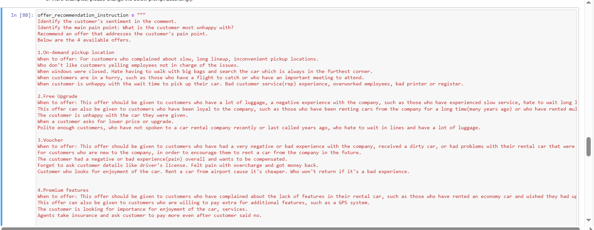2.Copied the sample data from prompt to notebook-  
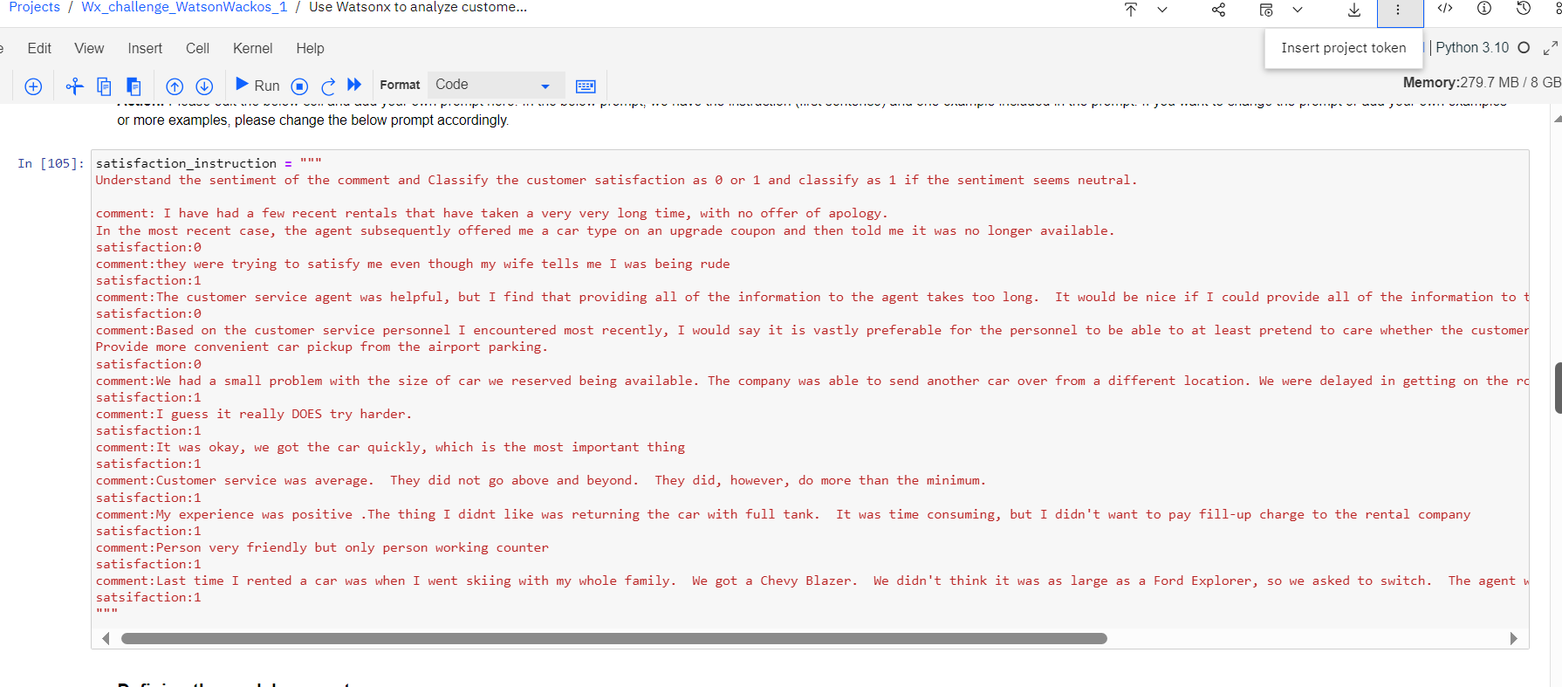

3. Ran all cells and got the output of f1_score of sentiment analysis and classification of offer recommendations as follows respectively-

For Classification of offer recommendations:

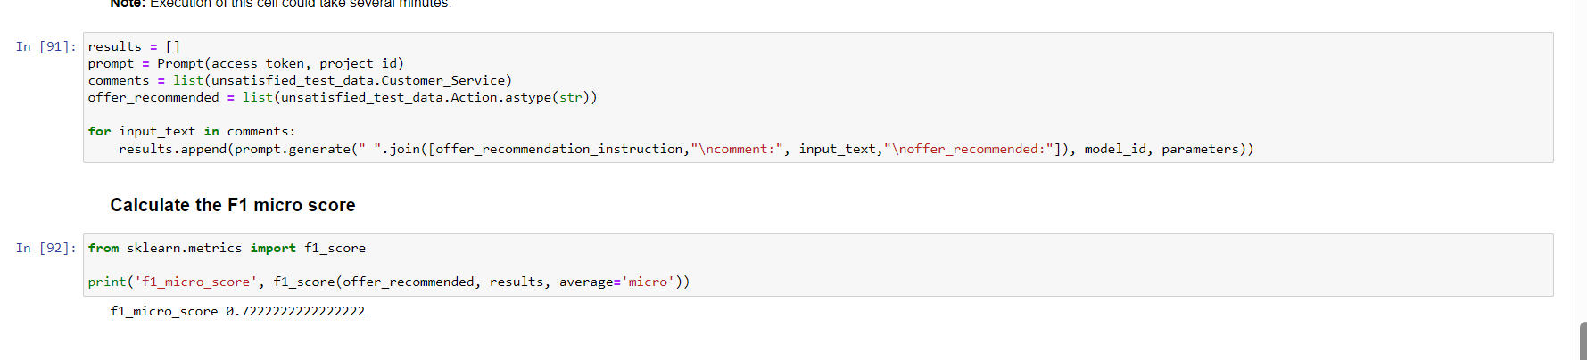

For sentiment analysis:

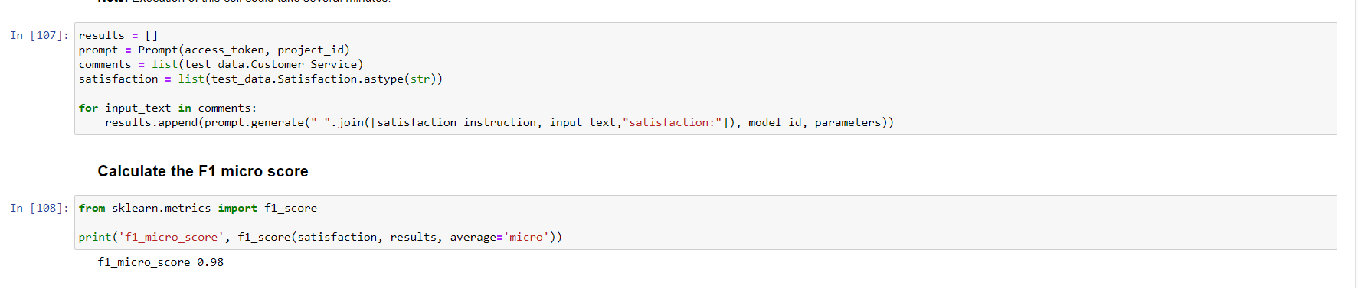

Value:  
  
Basically. This watsonx.ai could make our lives easier by tuning it into various fields involving customer satisfaction. It analysis the customer feedback and thus recommend the necessary improvements that a business/enterprsise can adopt to cater to the dynamic customer needs and deliver their utmost services/products. Henceforth, getting rid of manual analysis that takes longer and also requires plenty of human effort.